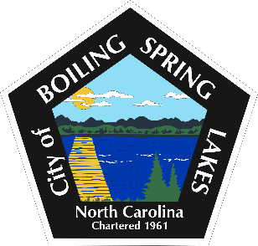

**City of Boiling Spring Lakes**

**Citizen’s Forum**

**Thursday, March 20, 2025 6:00 P.M.**

**City Hall**

1. **Call to Order- Mayor Jeff Winecoff**
2. **Pledge of Allegiance**
3. **Approval of the Agenda**
4. **Citizen’s Forum**
5. **Adjourn**