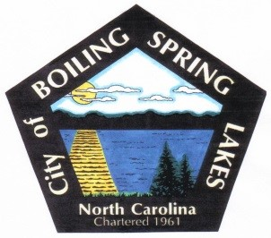**City of Boiling Spring Lakes**

**9 E. Boiling Spring Rd.**

**Boiling Spring Lakes, NC 28461**

**COMMUNITY APPEARANCE COMMITTEE**

**November 19, 2024**

**4:00 PM**

**City Hall**

* Call to Order
* Approval of Agenda
* Approval of Minutes
  + October 15, 2024
* Public Comment
* Old Business
  + Committee Funds
  + Yard of the Month
  + Best Holiday Decorations
  + Meeting Schedule
* New Business
  + None
* Other Business
* Adjourn