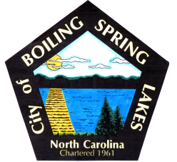 | City of Boiling Spring Lakes  9 East Boiling Spring Road  Boiling Spring Lakes, NC 28461

Library Commission Meeting Minutes
Boiling Spring Lakes City Hall
January 9, 2025, 10:00am
Agenda

I CALL TO ORDER

II APPROVAL OF AGENDA

III APPROVAL OF MINUTES

IV PUBLIC COMMENT

V OLD BUSINESS
- Training workshop in January
- Procedure List
- Facebook page management

VI NEW BUSINESS

VII PURCHASES & DONATIONS & BUDGET REVIEW

VIII ANNOUNCEMENTS

IX NEXT MEETING AGENDA ITEMS

X. ADJOURNMENT

