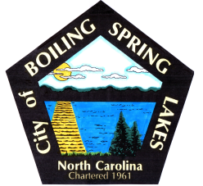 | City of Boiling Spring Lakes  9 East Boiling Spring Road  Boiling Spring Lakes, NC 28461

Library Commission
Boiling Spring Lakes City Hall
February 13, 10:00AM
AGENDA

I. CALL TO ORDER

II. APPROVAL OF AGENDA

III. APPROVAL OF MINUTES

IV. PUBLIC COMMENT

V. OLD BUSINESS
A. Training Workshop
B. Procedure List
C. Facebook Management
D. National Library Week

VI. NEW BUSINESS
- 2025/2026 Budget Request

VII. PURCHASES & DONATIONS & BUDGET REVIEW

VIII. ANNOUNCEMENTS

IX. NEXT MEETING AGENDA ITEMS

X. ADJOURNMENT

