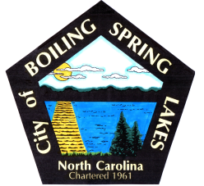 | City of Boiling Spring Lakes  9 East Boiling Spring Road  Boiling Spring Lakes, NC 28461

Library Commission
Boiling Spring Lakes City Hall
March 13, 2025
9:30AM
AGENDA

I. CALL TO ORDER

II. APPROVAL OF AGENDA

III. APPROVAL OF MINUTES

IV. PUBLIC COMMENT

V. OLD BUSINESS
- Training Workshop
- Facebook Management
- National Library Week

VI. NEW BUSINESS
- New Book purchases
- Maintenance of new purchase inventory

VII. PURCHASES & DONATIONS & BUDGET REVIEW

VIII. ANNOUNCEMENTS

IX. NEXT MEETING AGENDA ITEMS

X. ADJOURNMENT

