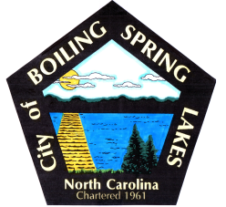 | City of Boiling Spring Lakes  9 East Boiling Spring Road  Boiling Spring Lakes, NC 28461

Special Events Committee
January 8, 2025
5:30 P.M.
City Hall

AGENDA

- Call to Order

- Approval of Agenda

- Approval of Minutes

- Public Comment

- Budget Report

- Old Business

a. Recap Christmas
b. 2025 Event Schedule
c. Eggstravaganza

- New Business

- Announcements

- Next Meeting Agenda Items

- Adjournment

