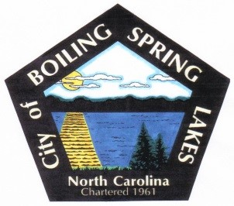**City of Boiling Spring Lakes**

**9 E. Boiling Spring Rd.**

**Boiling Spring Lakes, NC 28461**

**GRANTS COMMITTEE**

**November 9, 2025**

**4:30 PM**

**City Hall**

* Call to Order
* Roll Call
* Approval of Agenda
* Approval of Minutes
  + November 14, 2024
* Old Business
  + None
* New Business
* Discussion on potential grants/matching funds requirements.
* Final Comments/Questions/Concerns
* Adjourn