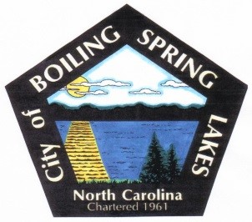**City of Boiling Spring Lakes**

**9 E. Boiling Spring Rd.**

**Boiling Spring Lakes, NC 28461**

**GRANTS COMMITTEE MEETING AGENDA**

**February 13, 2025, 4:30 PM**

**City Hall**

1. Call to Order
2. Roll Call
3. Approval of Agenda
4. Approval of Minutes
   1. November 14, 2024
5. Old Business
   1. None
6. New Business
   1. Discussion on potential grants/matching funds requirements.
7. Final Comments/Questions/Concerns
8. Adjourn