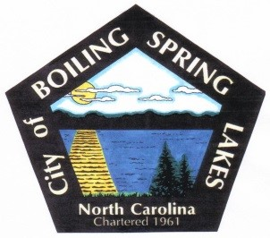
City of Boiling Spring Lakes
9 E. Boiling Spring Rd.
Boiling Spring Lakes, NC 28461

GRANTS COMMITTEE MEETING AGENDA
April 10, 2025, 4:30 PM
City Hall

- Call to Order

- Roll Call

- Approval of Agenda

- Approval of Minutes

March 13, 2025

- Old Business

None

- New Business

None

- Final Comments/Questions/Concerns

- Adjourn

