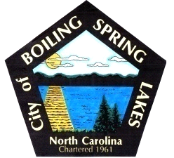 | City of Boiling Spring Lakes  9 East Boiling Spring Road  Boiling Spring Lakes, NC 28461

Parks and Recreation Advisory Board
Wednesday, February 19, 2025
6:00 P.M.

AGENDA

- Call to Order
- Introductions
- Approval of Agenda
- Approval of Minutes
- Director’s Monthly Report
- Standing Committee Reports
  - Review of Committee Responsibilities
  - Communications
  - Facilities
  - Department
- Public Comments
  - Lora Starkey - Lower Cape Fear Wildlife chapter of the NC Wildlife Federation. Creation of Venus Flytrap trail/education area
- Old Business
  - ADA Compliance
    - Accessibility
    - Hearing loss
  - Support for the P&R department 2025 goals
  - Review of Master Plan
- New Business
  - Dog park interest
- Next meeting agenda Items
- Announcements
- Adjourn

