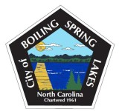
Board of Commissioners Budget Workshop Agenda
Monday, April 14, 2024
City Hall - 9:00 AM

- Call to Order
- Pledge of Allegiance
- Approval of Agenda
- FY 2025-26 Budget Workshop
- Adjourn

