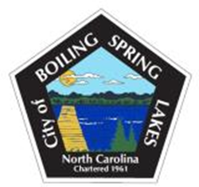

Board of Commissioners – Budget Workshop Agenda

Wednesday, January 15, 2025

City Hall - 4:30 PM

1. Call to Order- Mayor Winecoff
2. Pledge of Allegiance
3. Approval of the Budget Workshop Agenda
4. Establishing Budget Goals for Fiscal Year 2025-2026 by the Board of Commissioners.
5. Adjourn